**ScienceQtech Employee Performance Mapping.**

**1.Create database employee;**

* **use employee;**
* **select * from emp_record_table;**

**2.Entity Relation Diagram**

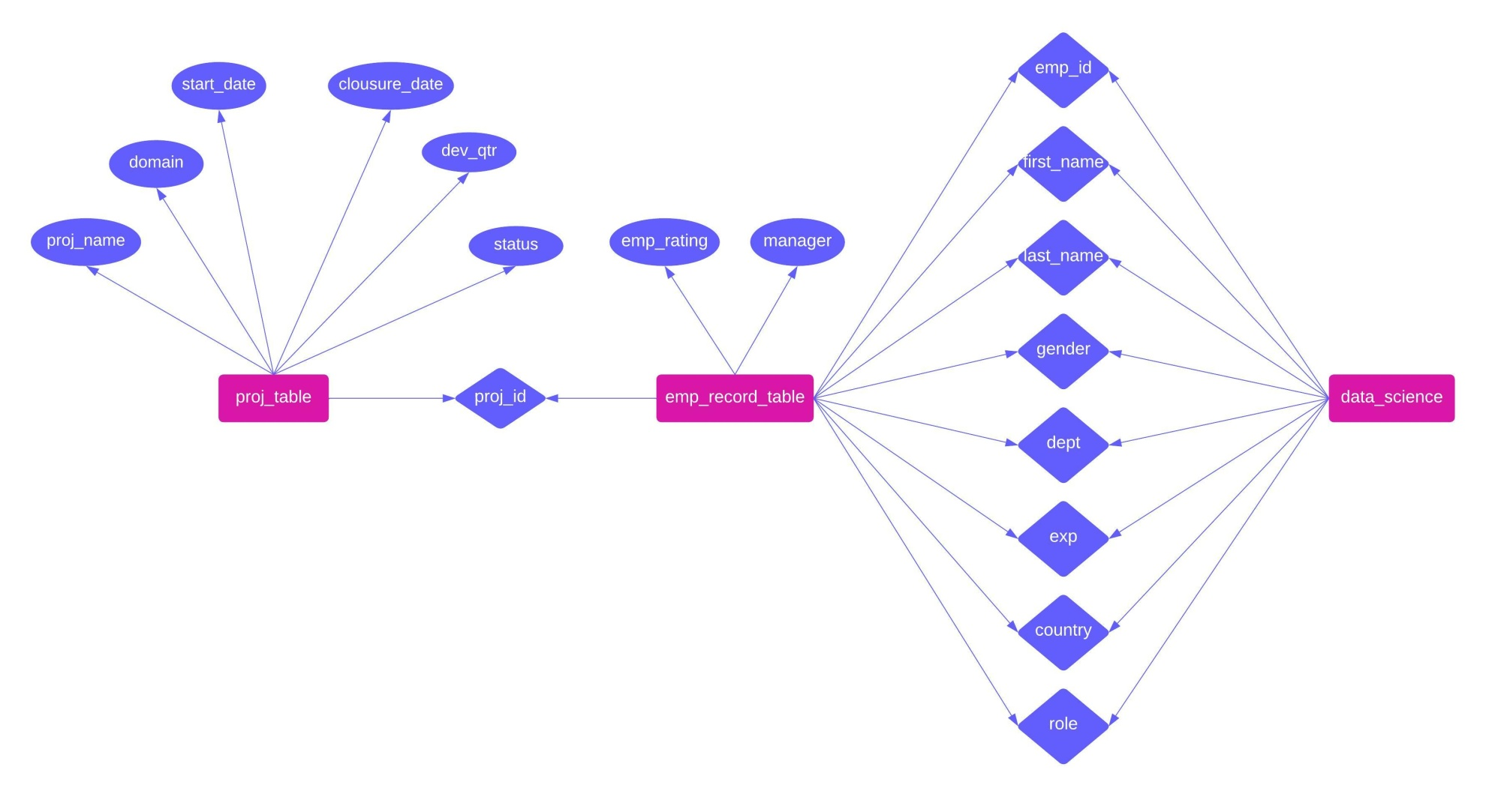

**3**.**select emp_id,first_name,last_name,gender,dept from emp_record_table;**

|  |  |  |  |  |
| --- | --- | --- | --- | --- |
| emp_id | first_name | last_name | gender | dept |
| E001 | Arthur | Black | M | ALL |
| E005 | Eric | Hoffman | M | FINANCE |
| E010 | William | Butler | M | AUTOMOTIVE |
| E052 | Dianna | Wilson | F | HEALTHCARE |
| E057 | Dorothy | Wilson | F | HEALTHCARE |
| E083 | Patrick | Voltz | M | HEALTHCARE |
| E103 | Emily | Grove | F | FINANCE |
| E204 | Karene | Nowak | F | AUTOMOTIVE |
| E245 | Nian | Zhen | M | RETAIL |
| E260 | Roy | Collins | M | RETAIL |
| E403 | Steve | Hoffman | M | FINANCE |
| E428 | Pete | Allen | M | AUTOMOTIVE |
| E478 | David | Smith | M | RETAIL |
| E505 | Chad | Wilson | M | HEALTHCARE |
| E532 | Claire | Brennan | F | AUTOMOTIVE |
| E583 | Janet | Hale | F | RETAIL |
| E612 | Tracy | Norris | F | RETAIL |
| E620 | Katrina | Allen | F | RETAIL |
| E640 | Jenifer | Jhones | F | RETAIL |

**4.select emp_id,first_name,last_name,gender,dept,emp_rating from emp_record_table**

**where emp_rating>4;**

|  |  |  |  |  |  |
| --- | --- | --- | --- | --- | --- |
| emp_id | first_name | last_name | gender | dept | emp_rating |
| E001 | Arthur | Black | M | ALL | 5 |
| E052 | Dianna | Wilson | F | HEALTHCARE | 5 |
| E083 | Patrick | Voltz | M | HEALTHCARE | 5 |
| E204 | Karene | Nowak | F | AUTOMOTIVE | 5 |

**4.select emp_id,first_name,last_name,gender,dept,emp_rating from emp_record_table**

**where emp_rating between 2 and 4;**

|  |  |  |  |  |  |
| --- | --- | --- | --- | --- | --- |
| emp_id | first_name | last_name | gender | dept | emp_rating |
| E005 | Eric | Hoffman | M | FINANCE | 3 |
| E010 | William | Butler | M | AUTOMOTIVE | 2 |
| E103 | Emily | Grove | F | FINANCE | 4 |
| E245 | Nian | Zhen | M | RETAIL | 2 |
| E260 | Roy | Collins | M | RETAIL | 3 |
| E403 | Steve | Hoffman | M | FINANCE | 3 |
| E428 | Pete | Allen | M | AUTOMOTIVE | 4 |
| E478 | David | Smith | M | RETAIL | 4 |
| E505 | Chad | Wilson | M | HEALTHCARE | 2 |
| E583 | Janet | Hale | F | RETAIL | 2 |
| E612 | Tracy | Norris | F | RETAIL | 4 |
| E640 | Jenifer | Jhones | F | RETAIL | 4 |

4.select emp_id,first_name,last_name,gender,dept,emp_rating from emp_record_table

where emp_rating<2;

|  |  |  |  |  |  |
| --- | --- | --- | --- | --- | --- |
| emp_id | first_name | last_name | gender | dept | emp_rating |
| E057 | Dorothy | Wilson | F | HEALTHCARE | 1 |
| E532 | Claire | Brennan | F | AUTOMOTIVE | 1 |
| E620 | Katrina | Allen | F | RETAIL | 1 |

**5.select first_name,last_name,concat(first_name,last_name) as name,dept from emp_record_table**

**where dept='finance';**

|  |  |  |  |
| --- | --- | --- | --- |
| first_name | last_name | name | dept |
| Eric | Hoffman | EricHoffman | FINANCE |
| Emily | Grove | EmilyGrove | FINANCE |
| Steve | Hoffman | SteveHoffman | FINANCE |

**6.select manager_id,count(emp_id) from emp_record_table**

**group by manager_id;**

|  |  |
| --- | --- |
| manager_id | count(emp_id) |
| NULL | 1 |
| E103 | 2 |
| E428 | 3 |
| E083 | 3 |
| E001 | 5 |
| E583 | 3 |
| E612 | 2 |

**7.select emp_id, dept from emp_record_table where dept='healthcare'**

**union**

**select emp_id,dept from emp_record_table where dept='finance';**

|  |  |
| --- | --- |
| emp_id | dept |
| E052 | HEALTHCARE |
| E057 | HEALTHCARE |
| E083 | HEALTHCARE |
| E505 | HEALTHCARE |
| E005 | FINANCE |
| E103 | FINANCE |
| E403 | FINANCE |

**8.select emp_id,first_name,last_name,gender,dept,emp_rating,max(emp_rating) over (partition by dept)**

**as maxemp_rating from emp_record_table;**

|  |  |  |  |  |  |  |
| --- | --- | --- | --- | --- | --- | --- |
| emp_id | first_name | last_name | gender | dept | emp_rating | maxemp_rating |
| E001 | Arthur | Black | M | ALL | 5 | 5 |
| E010 | William | Butler | M | AUTOMOTIVE | 2 | 5 |
| E204 | Karene | Nowak | F | AUTOMOTIVE | 5 | 5 |
| E428 | Pete | Allen | M | AUTOMOTIVE | 4 | 5 |
| E532 | Claire | Brennan | F | AUTOMOTIVE | 1 | 5 |
| E005 | Eric | Hoffman | M | FINANCE | 3 | 4 |
| E103 | Emily | Grove | F | FINANCE | 4 | 4 |
| E403 | Steve | Hoffman | M | FINANCE | 3 | 4 |
| E052 | Dianna | Wilson | F | HEALTHCARE | 5 | 5 |
| E057 | Dorothy | Wilson | F | HEALTHCARE | 1 | 5 |
| E083 | Patrick | Voltz | M | HEALTHCARE | 5 | 5 |
| E505 | Chad | Wilson | M | HEALTHCARE | 2 | 5 |
| E245 | Nian | Zhen | M | RETAIL | 2 | 4 |
| E260 | Roy | Collins | M | RETAIL | 3 | 4 |
| E478 | David | Smith | M | RETAIL | 4 | 4 |
| E583 | Janet | Hale | F | RETAIL | 2 | 4 |
| E612 | Tracy | Norris | F | RETAIL | 4 | 4 |
| E620 | Katrina | Allen | F | RETAIL | 1 | 4 |
| E640 | Jenifer | Jhones | F | RETAIL | 4 | 4 |

**9.select role,salary from emp_record_table**

**where salary = (select max(salary) from emp_record_table) or**

**salary = (select min(salary) from emp_record_table)**

**order by role desc;**

|  |  |
| --- | --- |
| role | salary |
| PRESIDENT | 16500 |
| JUNIOR DATA SCIENTIST | 2800 |

**10.select emp_id,exp,**

**rank() over(order by exp) as ranks from emp_record_table;**

|  |  |  |
| --- | --- | --- |
| emp_id | exp | ranks |
| E640 | 1 | 1 |
| E620 | 2 | 2 |
| E478 | 3 | 3 |
| E532 | 3 | 3 |
| E403 | 4 | 5 |
| E505 | 5 | 6 |
| E052 | 6 | 7 |
| E245 | 6 | 7 |
| E260 | 7 | 9 |
| E204 | 8 | 10 |
| E057 | 9 | 11 |
| E005 | 11 | 12 |
| E010 | 12 | 13 |
| E612 | 13 | 14 |
| E103 | 14 | 15 |
| E428 | 14 | 15 |
| E583 | 14 | 15 |
| E083 | 15 | 18 |
| E001 | 20 | 19 |

**11.create view employee_details as select emp_id,country,salary from emp_record_table**

**where salary>6000**

**order by salary desc;**

**select * from employee_details;**

|  |  |  |
| --- | --- | --- |
| emp_id | country | salary |
| E001 | USA | 16500 |
| E428 | GERMANY | 11000 |
| E103 | CANADA | 10500 |
| E583 | COLOMBIA | 10000 |
| E083 | USA | 9500 |
| E010 | FRANCE | 9000 |
| E005 | USA | 8500 |
| E612 | INDIA | 8500 |
| E057 | USA | 7700 |
| E204 | GERMANY | 7500 |
| E260 | INDIA | 7000 |
| E245 | CHINA | 6500 |

**12.select emp_id,first_name,last_name,role,dept,country,salary,exp from emp_record_table where exp in (select exp from emp_record_table where exp>10);**

|  |  |  |  |  |  |  |  |
| --- | --- | --- | --- | --- | --- | --- | --- |
| emp_id | first_name | last_name | role | dept | country | salary | exp |
| E005 | Eric | Hoffman | LEAD DATA SCIENTIST | FINANCE | USA | 8500 | 11 |
| E010 | William | Butler | LEAD DATA SCIENTIST | AUTOMOTIVE | FRANCE | 9000 | 12 |
| E612 | Tracy | Norris | MANAGER | RETAIL | INDIA | 8500 | 13 |
| E103 | Emily | Grove | MANAGER | FINANCE | CANADA | 10500 | 14 |
| E428 | Pete | Allen | MANAGER | AUTOMOTIVE | GERMANY | 11000 | 14 |
| E583 | Janet | Hale | MANAGER | RETAIL | COLOMBIA | 10000 | 14 |
| E083 | Patrick | Voltz | MANAGER | HEALTHCARE | USA | 9500 | 15 |
| E001 | Arthur | Black | PRESIDENT | ALL | USA | 16500 | 20 |

**13.delimiter //**

**create procedure emp_info(in var int)**

**begin**

**select emp_id,exp from emp_record_table ;**

**end //**

**delimiter ;**

**call emp_info(3);**

|  |  |
| --- | --- |
| emp_id | exp |
| E001 | 20 |
| E005 | 11 |
| E010 | 12 |
| E052 | 6 |
| E057 | 9 |
| E083 | 15 |
| E103 | 14 |
| E204 | 8 |
| E245 | 6 |
| E260 | 7 |
| E403 | 4 |
| E428 | 14 |
| E478 | 3 |
| E505 | 5 |
| E532 | 3 |
| E583 | 14 |
| E612 | 13 |
| E620 | 2 |
| E640 | 1 |

**14.select emp_id,country,exp,**

**case**

**when exp <=2 then 'junior data scientist'**

**when exp between 2 and 5 then 'associate data scientist'**

**when exp between 5 and 10 then 'senior data scientist'**

**when exp between 10 and 12 then 'lead data scientist'**

**when exp between 12 and 16 then 'manager'**

**end as employee_level**

**from data_science_team;**

|  |  |  |  |
| --- | --- | --- | --- |
| emp_id | country | exp | employee_level |
| E005 | USA | 11 | lead data scientist |
| E010 | FRANCE | 12 | lead data scientist |
| E052 | CANADA | 6 | senior data scientist |
| E057 | USA | 9 | senior data scientist |
| E204 | GERMANY | 8 | senior data scientist |
| E245 | CHINA | 6 | senior data scientist |
| E260 | INDIA | 7 | senior data scientist |
| E403 | USA | 4 | associate data scientist |
| E478 | COLOMBIA | 3 | associate data scientist |
| E505 | CANADA | 5 | associate data scientist |
| E532 | GERMANY | 3 | associate data scientist |
| E620 | INDIA | 2 | junior data scientist |
| E640 | COLOMBIA | 1 | junior data scientist |

**15.create index employee_index on emp_record_table (first_name);**

**15.select emp_id,first_name,last_name,role,dept,country,salary,exp from emp_record_table where first_name like 'eric%';**

|  |  |  |  |  |  |  |  |
| --- | --- | --- | --- | --- | --- | --- | --- |
| emp_id | first_name | last_name | role | dept | country | salary | exp |
| E005 | Eric | Hoffman | LEAD DATA SCIENTIST | FINANCE | USA | 8500 | 11 |

**16.select emp_id, round((5/100 * salary * emp_rating),2) as bonus from emp_record_table;**

|  |  |
| --- | --- |
| emp_id | bonus |
| E001 | 4125 |
| E005 | 1275 |
| E010 | 900 |
| E052 | 1375 |
| E057 | 385 |
| E083 | 2375 |
| E103 | 2100 |
| E204 | 1875 |
| E245 | 650 |
| E260 | 1050 |
| E403 | 750 |
| E428 | 2200 |
| E478 | 800 |
| E505 | 500 |
| E532 | 215 |
| E583 | 1000 |
| E612 | 1700 |
| E620 | 150 |
| E640 | 560 |

**17.select continent,country,round(avg(salary),2) as avg_salary from emp_record_table**

**group by country;**

|  |  |  |
| --- | --- | --- |
| continent | country | avg_salary |
| NORTH AMERICA | USA | 9440 |
| EUROPE | FRANCE | 9000 |
| NORTH AMERICA | CANADA | 7000 |
| EUROPE | GERMANY | 7600 |
| ASIA | CHINA | 6500 |
| ASIA | INDIA | 6166.67 |
| SOUTH AMERICA | COLOMBIA | 5600 |